**ASSIGMENT JAVA DAY17**

**Harshit Kushmakar| 16896**

1. **Create a JAR file of the BRD 1 – Validation Functions and install it in the .m2 repository. Use the same as a dependency in another Project and call the Validation methods to test the inclusion.**

package com.validation.kushmakar;  
  
import java.time.LocalDate;  
import java.time.format.DateTimeFormatter;  
import java.util.List;  
  
public class Validation {  
 public boolean dataTypeValidation(Object fieldValue, String dataType) {  
 if(dataType.equals(fieldValue.getClass().getSimpleName())){  
 return true;  
 }  
 return false;  
 }  
  
 public boolean dataLengthValidation(Object value, int maxLength){  
 if(value.toString().length()<=maxLength){  
 return true;  
 }  
 return false;  
 }  
  
 public boolean specialCharacterValidation(String value, String specialChar) {  
 for (int i = 0; i < specialChar.length(); i++) {  
 if (value.contains(specialChar.charAt(i) + "")) {  
 return true;  
 }  
 }  
 return false;  
 }  
  
 public <T> boolean domainValueValidation(Object value, List<T> domain){  
 for(T t:domain){  
 if(value.equals(t)){  
 return true;  
 }  
 }  
 return false;  
 }  
  
  
 public boolean formatValidation(LocalDate value, String format){  
 DateTimeFormatter formatObj = DateTimeFormatter.*ofPattern*(format);  
 String newValue = value.format(formatObj);  
 if(newValue.equals(value.toString())){  
 return true;  
 }  
 return false;  
 }  
  
  
 public boolean validateEmail(String email)  
 {  
 if(email.contains("@")&& email.contains(".com")&&!email.contains(" ")){  
 return true;  
 }  
 return false;  
 }  
  
}

**main:**

package com.validation.kushmakar;  
  
import java.time.LocalDate;  
import java.util.ArrayList;  
import java.util.List;  
  
public class ValidationMain {  
 public static void main(String[] args) {  
 int a = 90;  
  
 Validation validation = new Validation();  
 System.*out*.println(validation.dataTypeValidation(a, "Integer"));  
 System.*out*.println(validation.dataLengthValidation(100000, 1));  
 System.*out*.println(validation.specialCharacterValidation("hhhj", "#"));  
 List<Integer> domainList = new ArrayList<>();  
 domainList.add(5);  
 domainList.add(6);  
 domainList.add(7);  
  
 System.*out*.println(validation.domainValueValidation(7, domainList));  
 System.*out*.println(LocalDate.*now*());  
 System.*out*.println(validation.formatValidation(LocalDate.*now*(), "YYYY-MM-DD"));  
 System.*out*.println(validation.validateEmail("abc@email.com"));  
  
  
 }  
}

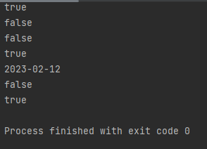**OUTPUT**

**Created a tester class and Added dependency of Brd-validation in pom.xml and build it.**

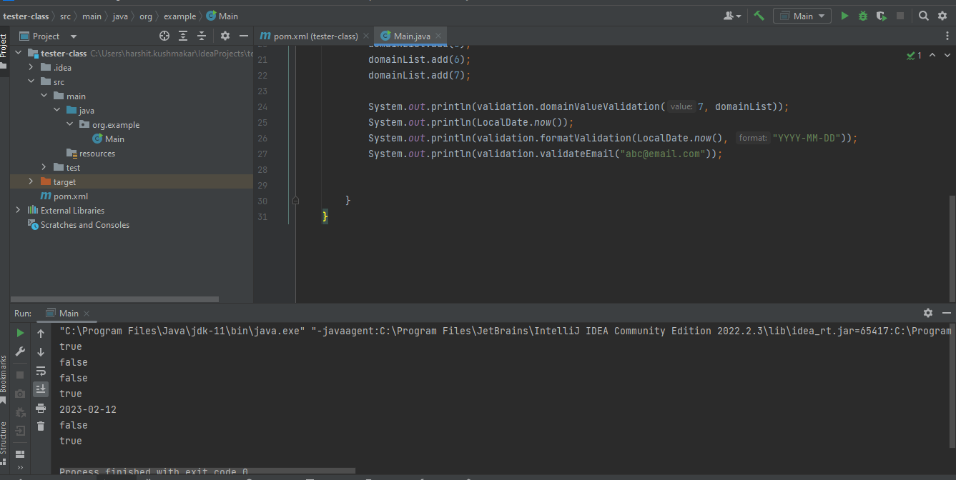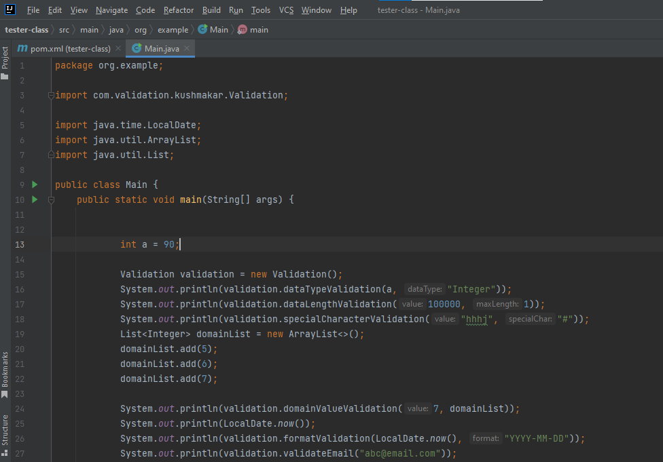**output(**created a tester class in the new project to call the methods**).**

**.jar file of BRD-Validation.**

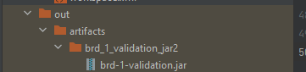

**2. Given below is the class diagram for the classes already created during the Inheritance and Collections assignments. Reuse the same classes. Create multi-module project for the above diagram as mentioned below:**

**1. Take Bank class in module1 and rest of the classes in module2.**

**2. Main class is in module1.**

**Test the functionalities.**

**3. Import this Project using SVN and perform the checkout, update, revert commands on it.**